Katrina Abad

Chapter 7 Lab Assignment

1. 7,960,000
2. South Atlanta; Pacific Region
3. X.
4. Standalone table
5. District ID would be a good key, because it is unique for each row and is in both tables.
6. Cardinality is from the subregions to districts, because there are many districts within one subregion.
7. 21 representatives are from new england states
8. The temperature in the west may be more scattered around a latitude band because the climate along the west coast is more temperate than that in the East Coast. For instance, northern CA and Washington are known for its rainy temperate weather, and southern CA for its heat- on the other hand, most of the states on the East Coast are known to experience more extreme weather conditions (below freezing in the winter and high temperatures in the summer).

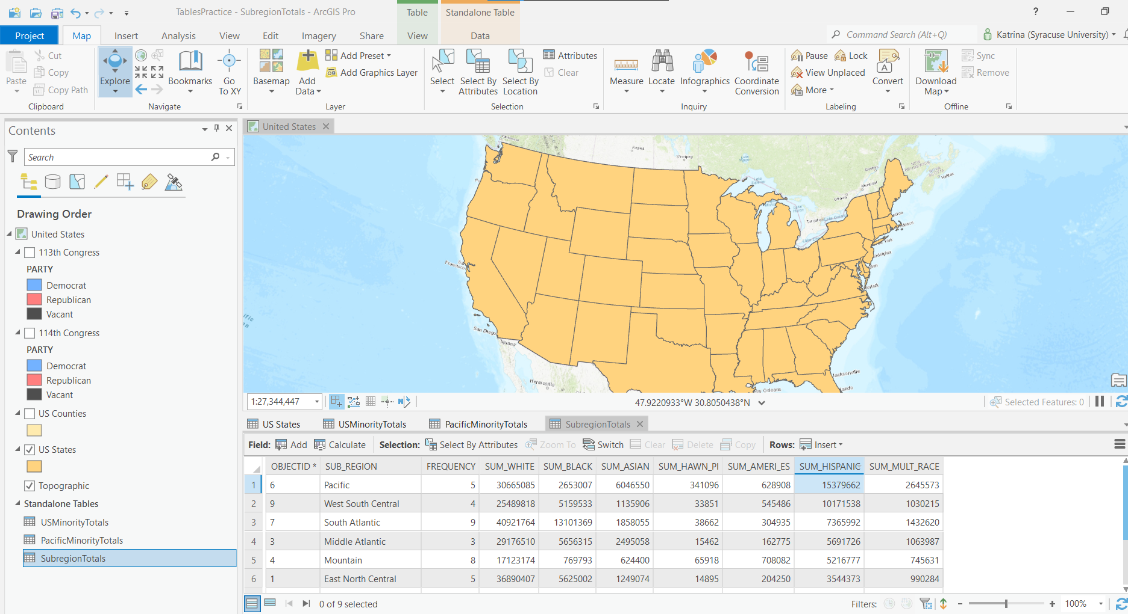

Step 8

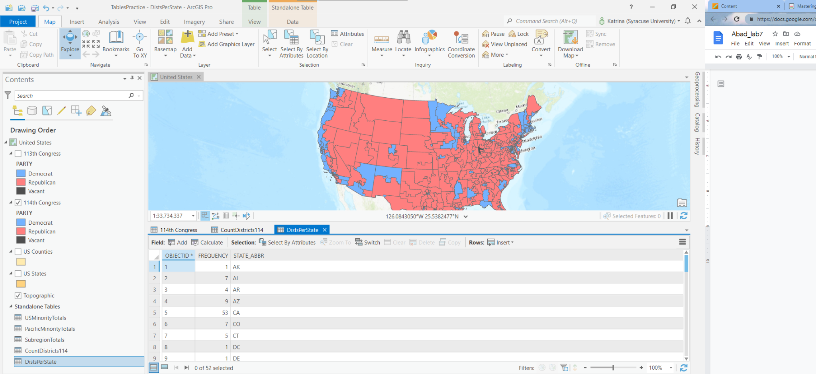

Step 12

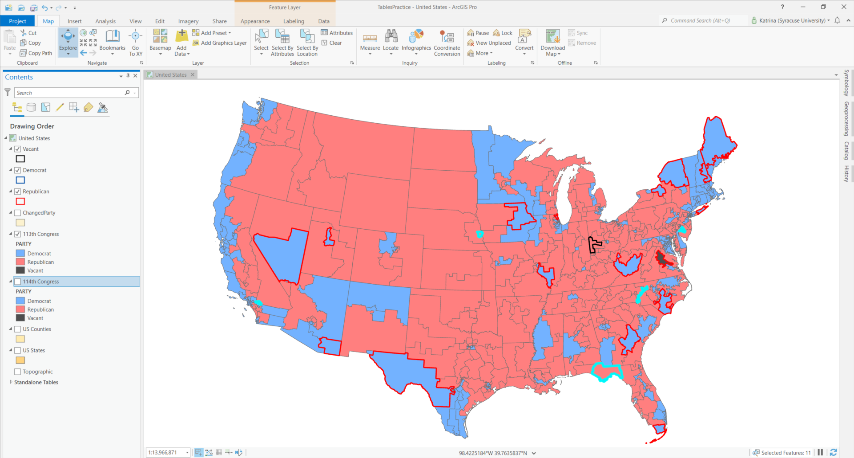

**Step 22**

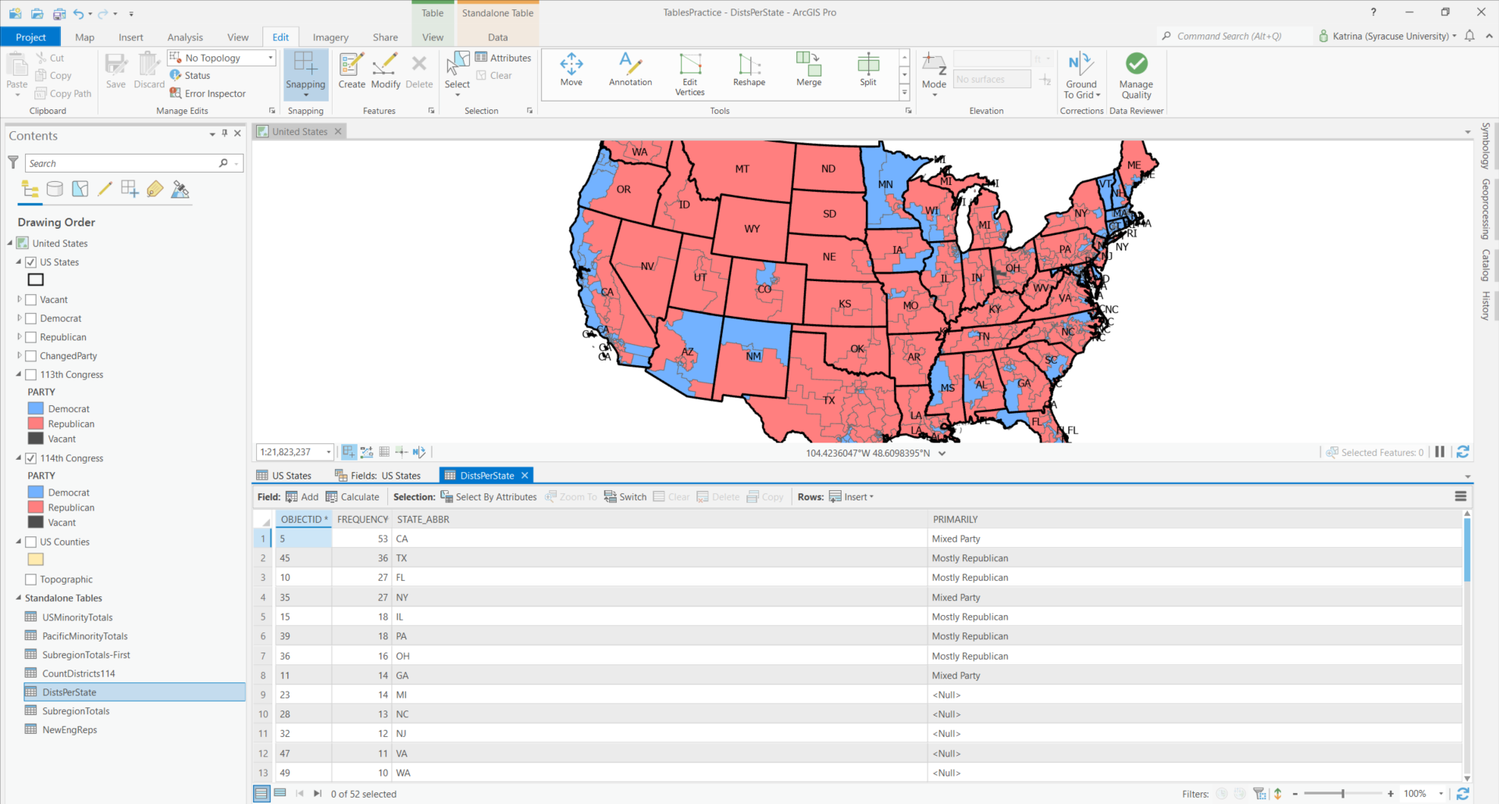

**Step 36**

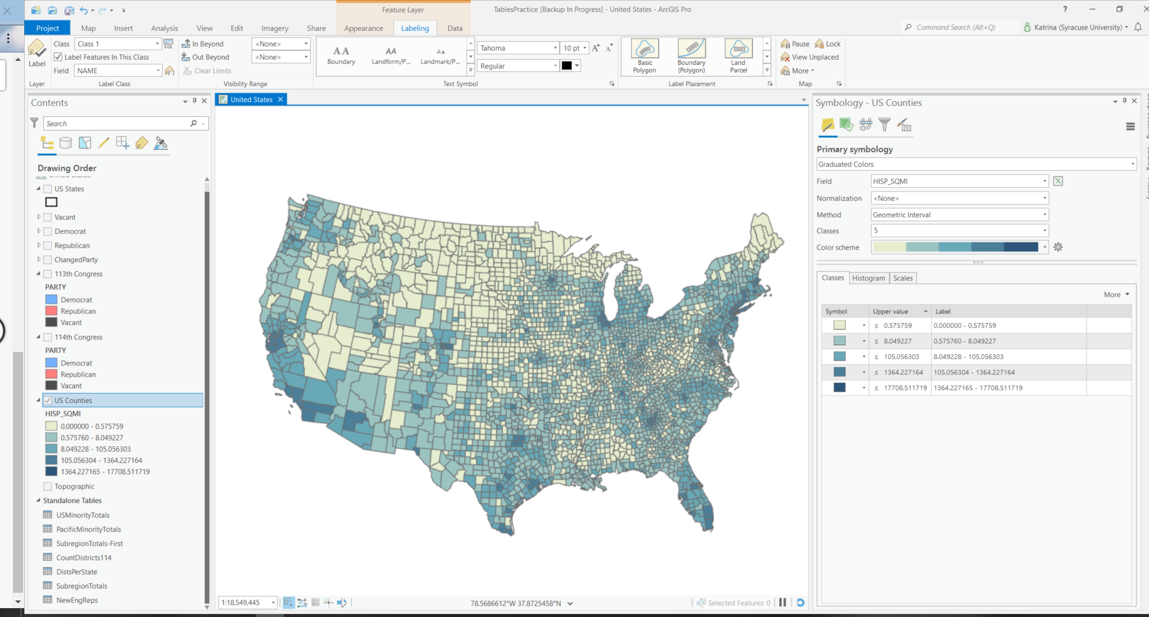

**Step 41**

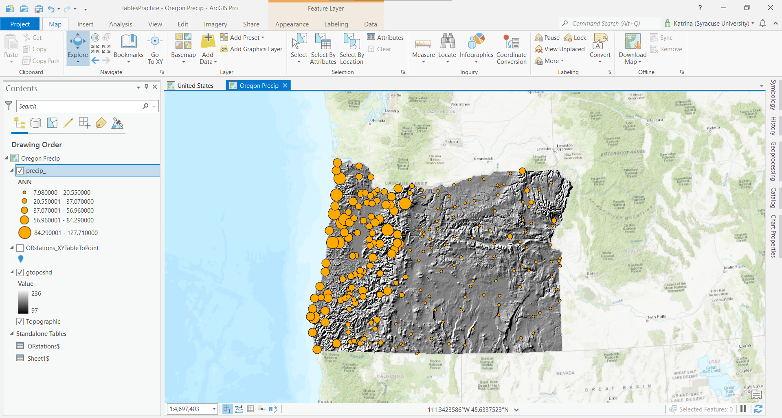

**Step 54**

**Xiewei’s Notes**

**Step 5**

Do not add space for output names (applies to all notes in the future), because output names are not cosmetic anymore

Party comes from the multiple layers

Find out where the districts where the party is changed in the something loads

**Step 21**

The expression should be set as *party =/= party*

SQL to verify inputs using figure 7.22 as reference

**Step 33**

Hit tab after completing each rule. When finished completing all 3 rows, delete the last, blank link row.

**Step 43**

You won’t find the list by charts panel, ignore the thing its says

**Step 49**

The oregon map is located under the maps folder